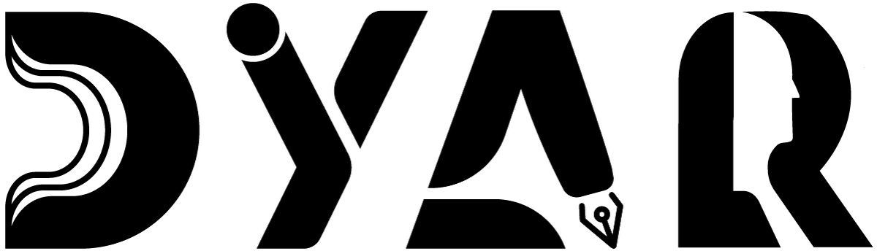
An NDIS Service Provider
RESOURCES HUB · EMP FEEDBACK
Emergency Management Plan — Feedback Form
Form to complete after every emergency or drill — what worked, what didn't, what DYAR should do differently.
Aligned to NDIS Practice Standards · NDIS Code of Conduct · NDIS Act 2013

Version 2 · 12 May 2026
DYAR Pty Ltd
NDIS Provider No. pending (Application 4-LRFP0J8) · ABN 68 695 255 504
Unit 1, 136 Main Street, Osborne Park WA 6017 · PO Box 8052, East Subiaco WA 6008
0470 540 306 · hello@dyar.com.au · Whadjuk Country

EMP Feedback Form
Tell us what worked + what didn't after an emergency or drill
After every emergency or drill, DYAR asks for your feedback. Your feedback helps us do better next time.
1. About the event
Date of event: _________________________________________________
Type of event: ☐ Fire ☐ Lockdown ☐ Bushfire ☐ Storm ☐ Medical ☐ Power outage ☐ Pandemic ☐ Drill ☐ Other
Where the event happened: _________________________________________________
How long it lasted: _________________________________________________
2. About you
Your name (optional — you can be anonymous): _________________________________________________
Your DYAR Participant ID (optional): _________________________________________________
Best way to contact you: _________________________________________________
3. What worked well?
Was your worker there to help you?: ☐ Yes ☐ No ☐ Not applicable
Did the DYAR plan match what actually happened?: ☐ Yes ☐ Mostly ☐ Not at all
What worked well during the event?: _________________________________________________
: _________________________________________________
: _________________________________________________
4. What didn't work well?
What was confusing?: _________________________________________________
What was scary?: _________________________________________________
What was missing?: _________________________________________________
Did anyone get hurt?: ☐ No ☐ Yes (please tell us)
5. What should DYAR do differently?
: _________________________________________________
: _________________________________________________
: _________________________________________________
6. Did you feel safe?
Overall, did you feel safe during the event?: ☐ Yes ☐ Mostly ☐ Sometimes ☐ No
If you didn't feel safe — what would have helped?: _________________________________________________
7. Anything else
Anything else you want to tell us: _________________________________________________
How to submit
Choose any of these:
• Email to hello@dyar.com.au
• Post to PO Box 8052, East Subiaco WA 6008
• Call Mehdi: 0470 540 306 — we can fill it in over the phone
• Hand to any DYAR worker
• Submit via the DYAR website form (dyar.com.au/feedback)
What DYAR does with your feedback
1. We thank you within 2 business days.
2. We review with the Director + (when active) the Lived Experience Advisory Group.
3. We update our Emergency Management Plan if needed.
4. We log it in our Continuous Improvement Register.
5. We tell you what we changed.
Your feedback after an emergency makes everyone safer next time. Thank you.
___________________________________________
DYAR Pty Ltd · ABN 68 695 255 504 · Unit 1, 136 Main Street, Osborne Park WA 6017 · 0470 540 306 · hello@dyar.com.au · dyar.com.au · Whadjuk Country · V1 19 May 2026

